Thermal Threat Detector User Manual
RIT Senior Capstone 2024

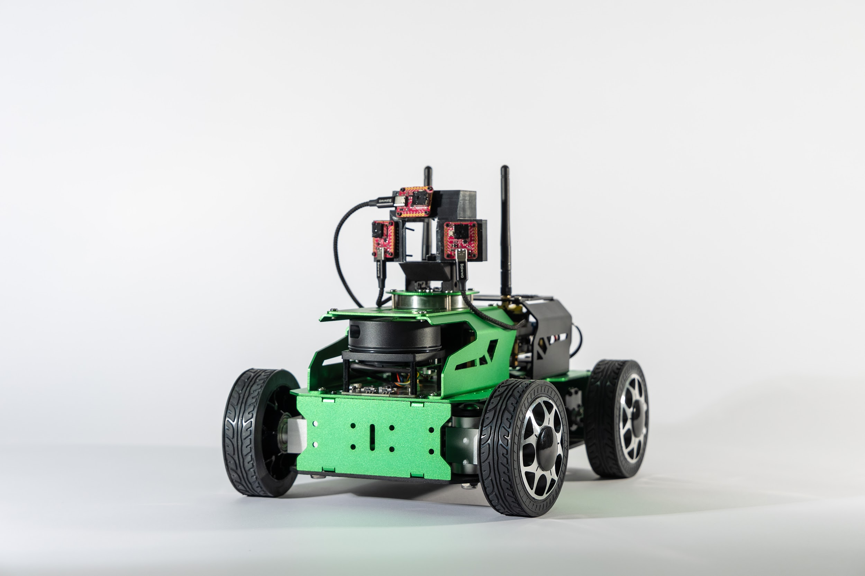

Table of Contents

Table of Contents 2
System Overview 3
System Requirements 3
Materials List/Packing List 3
Operational/Environmental Conditions 3
Initial Set up 3
Step-by-step Instructions for Installation and Assembly 3
Process of GUI Connection and User Registration 4
System Operation 7
Instruction for Motion Control 7
GUI Guide 7
Troubleshooting issues 8
Appendix 9
Frequently Asked Questions 9

System Overview

The thermal threat detector created by the Photographic sciences capstone class of 2024 is a vehicle equipped with a thermal camera system used to detect and identify threats in various high risk situations. With this vehicle, a team can survey and assess a potentially dangerous environment remotely without putting themselves in danger. This system gives the user a live view of the room in thermal imaging and allows them to capture data in real time with a GUI (graphical user interface). Additionally, this live view includes object detection to let the user know what threat is in frame.

System Requirements
Materials/Packing List
- JetAcker Standard Kit
- Jetson Nano
- Vehicle remote control
- Lepton 3.1r camera (x3)
- Purethermal 3 breakout board (x3)
- Camera mount
- 12 pack of M2*30 nuts, bolts and washer
- ¼-28 mounting screw and nut
- 11.1V 6000mAh lipo battery (x2)
- Battery charger
- Triple USB to USB bridge
- USB to USBC adaptor (x3)
- Viewing device (laptop)

Operational/Environmental Conditions
- Indoors
- Well lit, low light, or dark rooms
- Vehicle can be controlled from ~50 meters away through walls

Initial Set up
Step-by-step Instructions for Installation and Assembly
- Battery safety and charging
  - Turn the vehicle off and never use it when the battery is charging if it is left plugged into the vehicle.
  - Plug the charger into the wall and then plug the charging cable into corresponding DC5.5*2.5 cable on the battery.
  - A steady light will change from red to green on the charger to indicate that the battery is fully charged.
  - Unplug charger once the battery is finished charging to avoid over charging.
  - Once charged, plug the battery into the corresponding SM-2P cable on the vehicle. Do not directly plug the battery into the Jetson Nano.
- Mounting and setting up cameras
  - Using 4 small screws, attach the camera mount to the top of the vehicle.
  - Plug in the USB to USBCs from the bridge to each camera
  - Plug in the bridge to a usb port at the back of the jetson nano
  - Ensure that all switches on the usb bridge are switched on, a blue light will indicate a port has power connected.
- Connecting to the vehicle through NoMachine
  - Turn the vehicle on and connect a laptop to the vehicles wifi; HW-2D5C4453
  - Launch NoMachine and put “192.168.149.1” in the search bar
  - Choose “Configure connection to new host 192.168.149.1”, decide on a name for the vehicle, then click “Connect”
  - A login screen will appear and enter the username “Hiwonder” and password “Hiwonder” then select the box stating “Save this password in the connection file”
- Connecting to the remote controller
  - Make sure that the handle receiver is plugged into the correct USB port on the vehicle
  - Launch NoMachine, open a new terminal, and type in the command “sudo systemctl restart start_ap_node.service”
    - This will restart the vehicle
  - Turn on the remote control and check to make sure that a green LED light is lit up on the back of it
    - This means that the controller has paired with the vehicle

Process of GUI connection and user registration
- Click on the threat detector app in NoMachine

- Once the GUI initiates, enter username and password into the corresponding fields.
- If the credentials entered are for an existing account, click login.
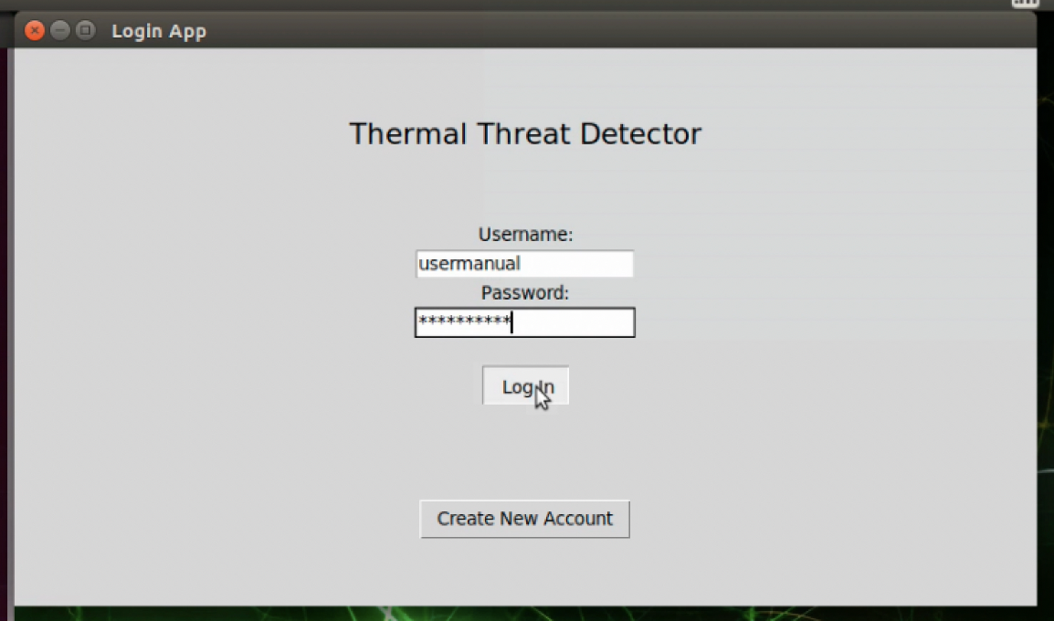
- If the credentials are for a new account, click create account. If ‘login’ is clicked when credentials are not from an existing account, an error message will appear and require that you click ‘create new account’ instead.
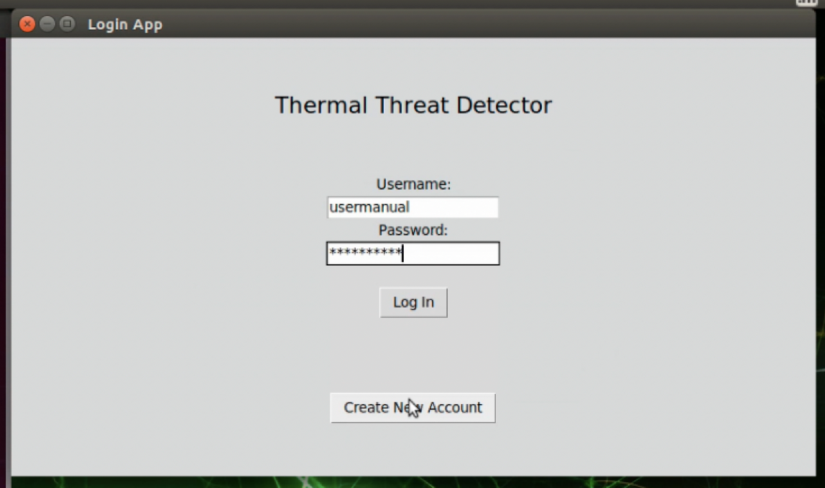

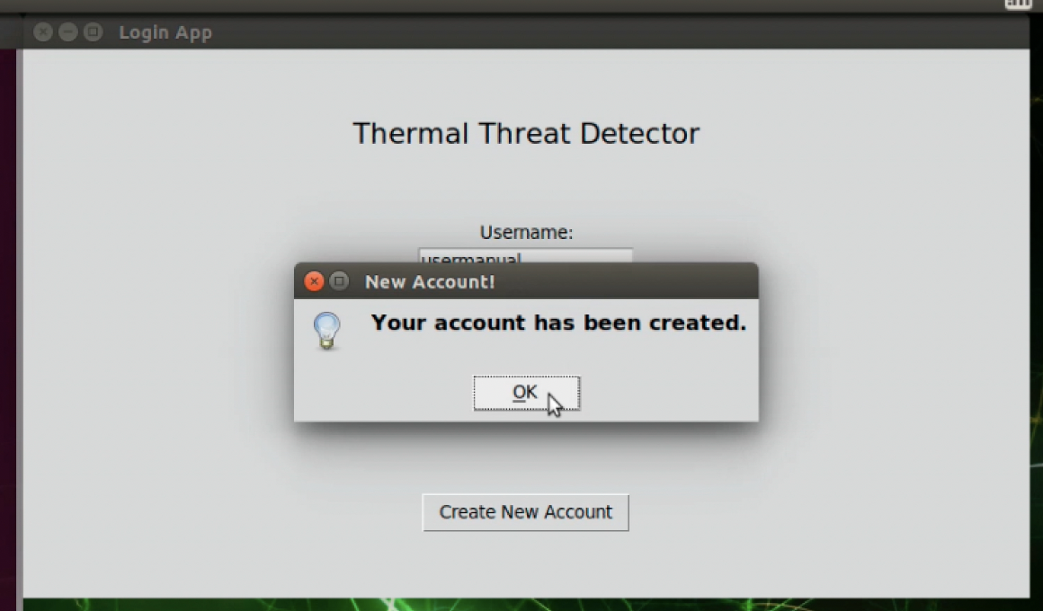
- Upon logging in, the main page of the GUI with live views will be displayed
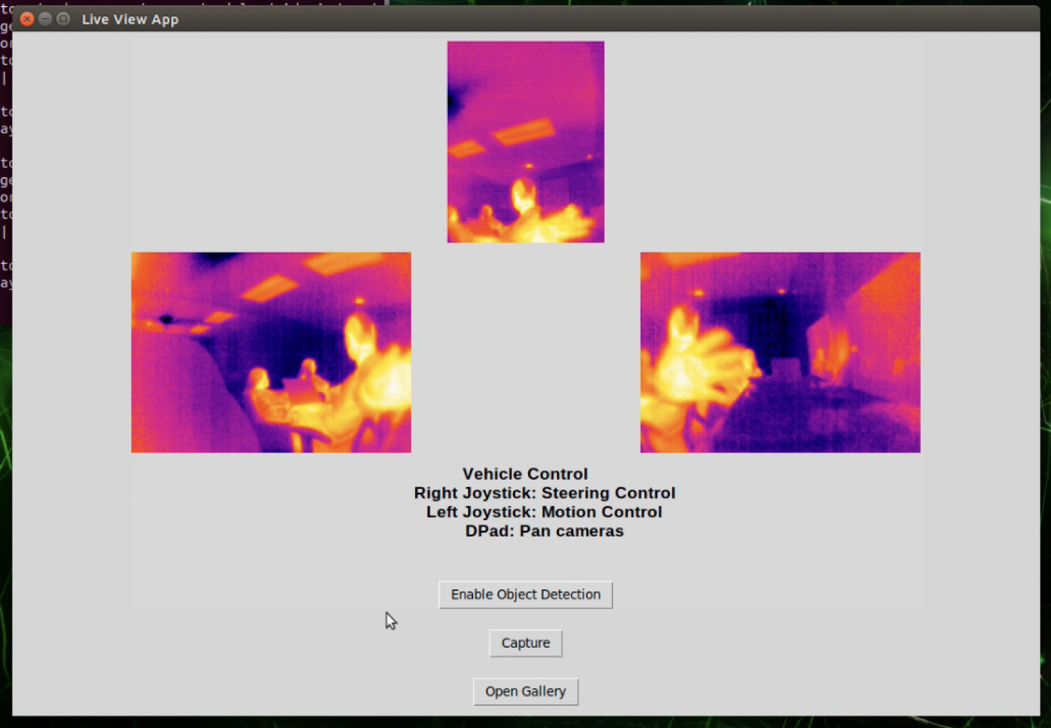
- A Logout button is available at the bottom center of the screen which will return the GUI to the login screen.
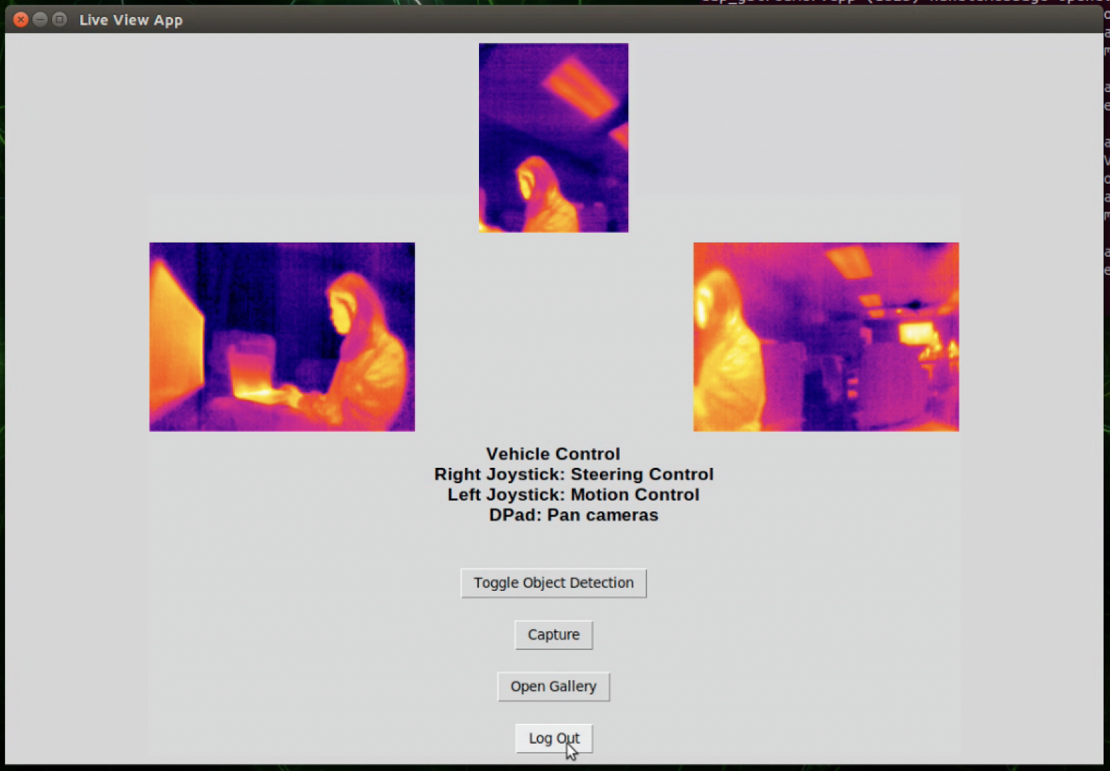

System Operation
Instruction for motion control
- Once the controller is paired with the vehicle:
  - Moving the left joystick upwards or downwards will allow the vehicle to move forward and backward
  - Moving the right joystick left and right will allow the vehicle to move left and right
  - The buttons in the D-Pad (located on the left hand side of the controller) will move the mount the cameras are connected to
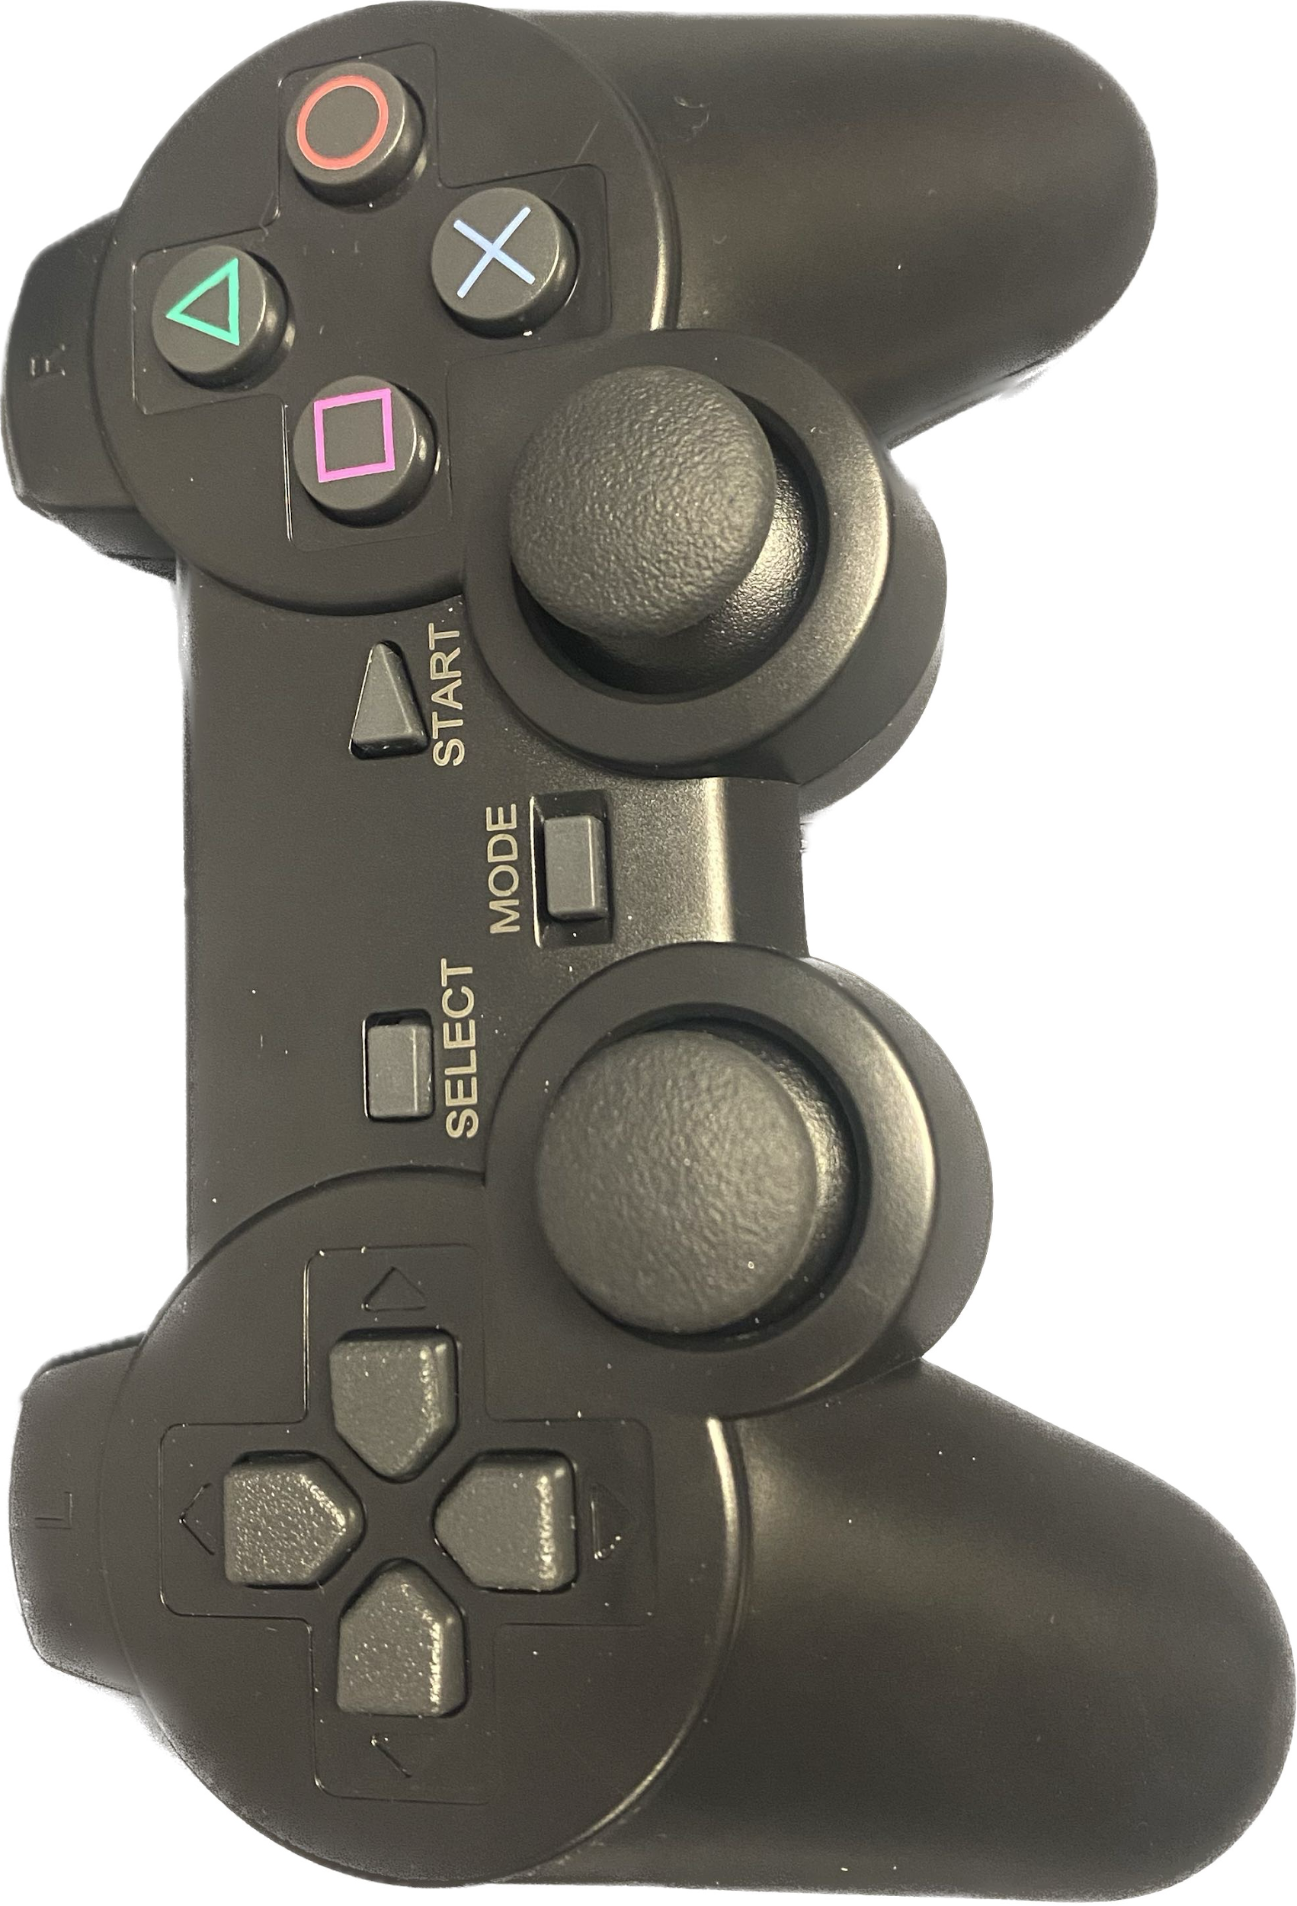

GUI Guide
- Once logged into the GUI, use the “toggle Object detection” button to enable and disable object detection.
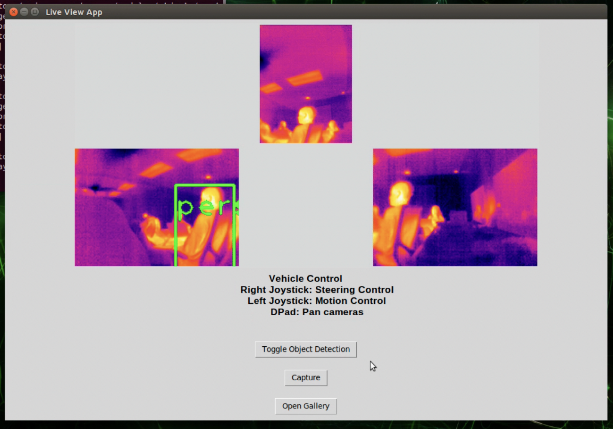
- Click “capture” to take a picture of the current live view.
- To view the capture, click “open gallery”. An additional pop up window will appear with the images from each window (multiple captures can be taken before opening/viewing the gallery).
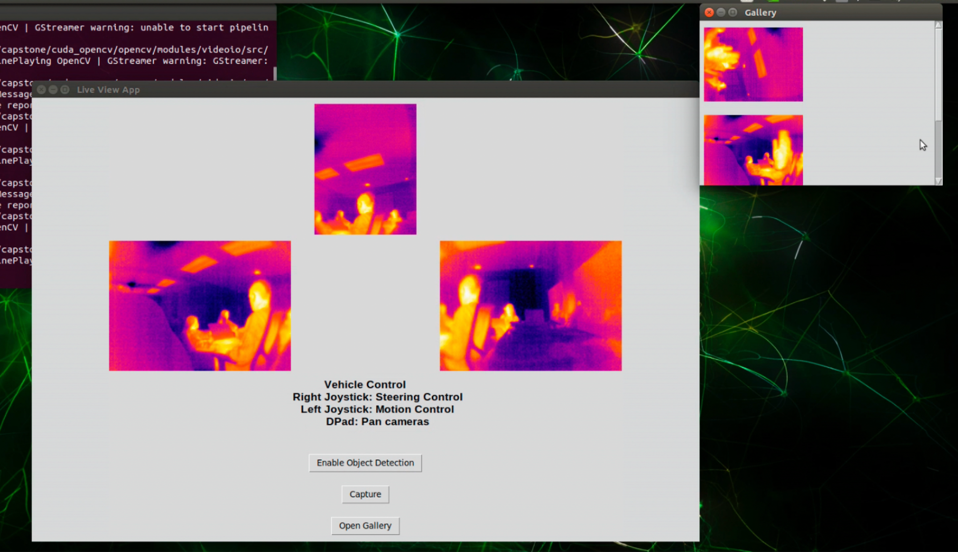

LIDAR mapping through NoMachine

Troubleshooting Issues
- If unable to connect to the vehicle through NoMachine:
  - Ensure that the device you are connecting on is connected to the vehicles wifi: HW-2D5C4453
  - Ensure that the code typed into the terminal matches that which was described in the JetAcker shared folder on Google Drive
- If unable to connect to the wireless controller:
  - Ensure that the controller is powered on by moving the switch
  - Turn the controller off and back on; once paired with the vehicle, a beeping sound will be heard
    - The controller will lose connection with the vehicle after sitting inactive for a period of time
- If unable to connect to the cameras:
  - Exit out of and reopen the Threat Detector application in NoMachine
    - It will take a few minutes for the application to open and an image from the cameras to appear
  - Reset the cameras by pressing the button on the breakout board
    - To disassemble the cameras from the mount, use an M2 Allen Wrench included in the tool kit

Appendix
Frequently Asked Questions
- What is the type of battery and estimated battery life?
  - The batteries are 11.1V 6000mAh lithium batteries with an estimated run time of about 4 hours
- What is the Lidar range on the vehicle?
  - The Lidar is able to range from 0.15-12 meters
- How fast is the vehicle?
  - The vehicle runs at a speed of about ½ meter per second
- What is the focal length on the cameras?
  - Each camera has a focal length of 1.1 millimeters
- What is the frame size of the cameras?
  - The frame size is 160x120 px
- What is the field of view of each camera?
  - Each camera has a 95 degree horizontal field of view and a 75 degree vertical field of view
- What is the thermal range that the cameras can capture?
  - The cameras are able to read temperatures from 10℃ to 450℃
- What is the microprocessor on the vehicle?
  - The microprocessor is the JetsonNano
- How does the user connect to the car?
  - The user is able to connect to the car by utilizing the wifi from the car and hacking into it through NoMachine

